Novo WebPort® Installation Guide 1

Introduction

This Installation Guide provides an overview of the available options to the Novo WebPort development environment where and how to install it. This is targeted to more experienced individuals and employees licensed to install WebPort on server clusters and local machines.

Chapter 2, “Getting ready” prepares the technician with the tools necessary to successfully process an installation of Novo WebPort by giving an overview of each of the steps. Chapter 3, “Scripting the database” describes the process of scratch-building the database (from release version 1.1.7) in Microsoft SQL Server 2005 and formatting the tables to work with WebPort. Chapter 4, “Building WebPort” explains how to set up, build, and publish the projects to IIS in Microsoft Visual Studio 2005. Chapter 5, “Finishing up” takes a step by step walk through a check list to verify the system has been properly installed and is functional. Chapter 6, “Setting security” introduces the concept of usernames, passwords, and access rights to be set up for the end-user.

What is in this Guide?

This contains all the information necessary:

● It lists the files needed from the factory for the particular version to be installed
● Includes reference to the external libraries use in the particular version to be installed
● Installation on single machines and managed servers and describes the installation and connectivity
● one more

Minimum Requirements for Installation

The absolute minimum requirements for a brisk performance of Novo WebPort as of the date of this publication are:

(on the host machines)
● A PC with an Intel processor (PC emulation supported in OS X)
● Microsoft Windows XP Professional SP2 or Windows Server 2003
● Microsoft SQL Server 2005
● At least 512MB RAM
● At least 30GB free hard disk space

Plus,

(on the technician’s machine)
● Microsoft Visual Studio Professional 2005 SP1

Typographic conventions

This manual uses the typefaces described below to indicate special text.

Table 1.1 Typographic conventions
Typeface | Meaning
Monospace type | Monospaced type represents text as it appears on screen or in code. It also represents anything you must type.
Boldface | Boldfaced words in text or code listings represent reserved words or compiler options.
Italics | Italicized words in text represent WebPort identifiers, such as variable or type names. Italics are also used to emphasize certain words, such as new terms.
Keycaps | This typeface indicates a key on your keyboard. For example, “Press Esc to exit a menu”.

2

Getting ready

This chapter explains what you need to get prepared for a full installation of Novo WebPort on either single or multiple machines running native or emulated Microsoft Windows on Intel machines.

Starting a WebPort Installation

Before installing WebPort, be certain to have the following criteria met:

● Your laptop should meet the minimum requirements and have all software installed before beginning
● You have checked out all the proper files and made sure they are the most current date
● You are aware of the security policies of transporting sensitive company files to a remote location
● You have verified the file system to be installed

The File Checkout

Login to the internal SVN Category at https://svn.novoport.com/webport/

You will see a listing by version of WebPort, choose the most current, at the time of publication of this document, it is v.1.1.7. Navigate until you find the current version ‘WebPort_v1.1.7’. Inside the folder you will find the following files/folders:

Figure 2.1 File Checkout
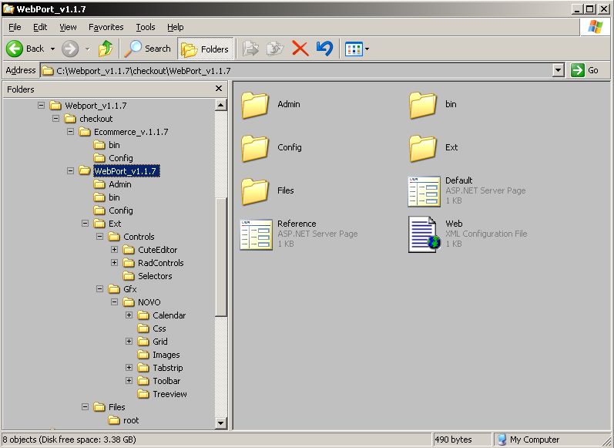

The checkout folder contains the core, WebPort_v.1.1.7, and an add-on module, Ecommerce_v.1.1.7. Check the version numbers before downloading the files for system installation; in this instance the version number match for the product and its add-on, but this is not always the case.

In the subfolder WebPort_v.1.1.7, you can see the following folders:

● Admin
● bin
● Config
● Ext
● Gfx
● Files

